
LDARD Farmer Support Application forms for 202
4
/2
5

financial year

2027/2028 PRODUCER SUPPORT APPLICATION FORM FOR
SMALLHOLDER, COMMERCIAL AND ORGANISED PRODUCERS

SECTION A - TERMS AND CONDITIONS

This terms and conditions must be read in full and signed at the bottom. Applicant must initialise each page.

Background
The Limpopo Department of Agriculture and Rural Development is issuing out this application form in terms of Producer Support Policy. Submission of applications will commence from 23 October 2026 to 30 November 2026. Only applications received on or before 23 November 2026, 16h30 that meet the minimum requirements and scored the necessary points after screening shall be prioritised for funding depending on budget availability. It is in the interest of all applicants to read and sign all documents. Applications should be hand delivered to the Local Agricultural Offices where the project is situated. It is the responsibility of the applicant to ensure that the application form is received on time and acknowledgement of receipt is obtained.

General qualifying criteria.

  - Applicants must be the citizens of the Republic of South Africa who are 18 years and above involved in agricultural or value adding activities within the borders of the Limpopo Province.
  - Applicants must be duly authorised to act on behalf of the legal entity that he/she is representing, where applicable.
  - Applications from public servants shall not be considered apart from traditional leaders. Public Servant refers to any persons working under the employ of the government of the Republic of South Africa, including public representatives at the national, provincial or municipal levels; an employee of any company or entity where the state is a majority shareholder. Public representative at national and local level shall only qualify for agricultural support after 12 months of terminating the relationship that had created a public duty.
  - All applicants must have a security of tenure or valid land use rights in respect of the land.
  - Project activities that require water use registration or licence in accordance with the National Water Act (Act 36 of 1998) regulations will only be considered for funding once proof of water use authorisation is provided. E.g. funding of irrigation related activities, feedlots etc.
  - Project activities that require compliance with Natural Resource Management related legislation will only be considered for funding once proof of legal requirements is provided. E.g. Environmental Impact Assessment (EIA) reports.

- Funding will be guided by the following principles.
Equity, Economic Viability, Value for money, Sustainable management of natural resources, Value chain approach, strengthen collaboration and coordination, Needs assessment and skills audit, Comprehensive needs-driven provision support to producers, Participatory planning, Community-Public-Private Partnerships, Responsibility and accountability

4. Scope of funding.
4.1 The department provides funding opportunities to producers through various programmes which covers the following:
4.1.1 Infrastructure development
4.1.2 Production inputs including but not limited to (procurement of seeds, seedlings, fertilizers, pesticides, herbicides, animal feeds, day old chicks, animal medications)
4.1.3 Provision of mechanization services.
4.1.4 Procurement of breeding stocks for intensive production system.
4.2 No cash transfer shall be made to any applicant in respect of the support requested. The funding method will be determined in line with the approved procedures.
4.3 Departmental funding is not a right but a means to encourage citizens to be self-sustainable and self-reliant.
4.4. The Department has the right not to award. The Department has the right to visit projects for verification as part of application assessment process. The Department has the right to demand or request additional information that will assist various committees to take informed decision.

- The following shall be considered when application is evaluated.
  - A fully completed and signed application form.
  - A completed business case.
  - A bankable business plan. – (applicable to medium and large-scale commercial producers)
  - Secured tenure arrangements. State-Owned and Land Reform Leased Land: For infrastructure development and permanent crop establishment, applicants must submit a valid lease agreement as proof of secure tenure. Short-term leases must be at least nine (9) years and eleven (11) months, while long-term leases must exceed thirty (30) years. Privately-Owned Leased Land: For infrastructure development and permanent crop establishment, applicants must submit a valid lease agreement of at least ten (10) years, where applicable, in accordance with the Subdivision of Agricultural Land Act 70 of 1970. The application must include a valid lease agreement, notarial lease where required, or the Minister’s or delegated authority’s written consent, as applicable.
  - Only one business enterprise with high returns per applicant will be considered for funding.

6. Target Beneficiaries
6.1. Small-holder producer- Smallholder producer is defined as a producer or entity that produces (at
primarily, secondary and tertiary for household consumption and markets, therefore farming is consciously undertaken to meet the needs of the households and derive a source of income. These are usually the entrants aspiring to produce for market at a profit with a maximum annual turnover ranging from R50 001 to R 1 million per annum. Smallholder producer falls within the General Authorization in (GA) as per Government Gazette Notice 398 of 26 March 2024.
6.2 Medium Scale Commercial Producer- Medium Scale Commercial Producer is defined individual or
entity that produces and sell agricultural commodities for the purpose to make a profit. These are established enterprises producing for the market to make a profit with an annual turnover ranging from R1,000,001 to R10 million and are eligible for VAT registration. Requires a water use license authorization in terms of section 40 of the NWA as defined in section 21 of the NWA except those which fall under existing lawful use.
6.3 Large cooperate Commercial Producers- Large scale commercial producer is defined as an individual
or entity that produces and sells agricultural commodities for the purpose to make a profit. These are established enterprises producing for market to make a profit with an annual turnover ranging from R10,000,001 to 50 million. Requires a water use license authorization in terms of section 40 of the NWA as defined in section 21 of the NWA except those which fall under existing lawful use.

6.4. Organized producers- Mega/corporate producer is defined as an individual or entity that produce
and sell agricultural commodities for the purpose to make a profit. These are established enterprises
producing for the market to make a profit with an annual turnover above R50 million. Requires a
water use license authorization in terms of section 40 of the NWA as defined in section 21 of the NWA,
except those which fall under existing lawfully use
6.5. Prioritised Group- Military Veterans (Individuals in South Africa who served in the country defence forces including
those from statutory and non-statutory forces and meet the criteria in the Military Veterans Act and listed in the National
Military Veteran’s Database.), Unemployed agriculture graduates (Qualified unemployed graduates in agriculture-
Related fields aspiring to venture into entrepreneurial projects related to agriculture production and value chain and
have completed the placement in the Limpopo Province), Traditional leaders

7. Conditions of assistance
7.1 Provision of support may only commence after: -
7.1.1. Signing of Memorandum of Agreement
7.1.2. Registration in the producer register database
7.1.3. The planning of works has been completed and approved.
7.1.4. Written approval thereto has been obtained from the Accounting Officer or delegated official.
7.1.5. Funding has been sourced and approved.
7.2 Completed work shall conform to departmental specifications and requirements.
7.3 Infrastructure works and equipment handed over must be maintained at the expenses of the applicant to the satisfaction of LDARD and may not be altered, destroyed, or removed without prior written permission of the Accounting Officer.
7.4 If a person to whom tangible assistance has been provided and later it is discovered that false information was provided; or has infringed or failed to comply with any conditions subject to which the assistance was made: -
7.4.1. LDARD may demand that such person refund the monetary value of the assistance
received, together with interest thereof calculated from the date of receipt.
7.4.2. Although the Department aid according to specifications and other advice in connection with the provision of production inputs, the department does not accept liability for anything provided in good faith.
7.7. Correspondence shall be limited to successful applicants only. If you have not received any communication from us within 90 days of the closing date, accept that your application was not successful. However, should there be any dissatisfaction, applicants are advised to follow processes of Promotion of Administrative Justice Act, 2000 (Act no 3 of 2000) as amended.
7.8. Full names of all the joint owners, partners or members must be provided, and the application must be signed by a nominated representative, in which case the power of attorney or resolution must be submitted. In the case of closed corporations, a copy of the founding statement or constitution is required.
7.9. Applicant’s declaration

7.9.1 Is the applicant, or any of its directors / trustees / shareholders / members / partners or any person having an interest in the enterprise, employed by the state? YES/NO

7.9.2. If so, furnish particulars of the names, individual identity numbers, and, if applicable, state employee numbers of sole proprietor/ directors / trustees / shareholders / members/ partners or any person having interest in the enterprise, in table below.

Full Name | Identity Number | State Institution

If the space provided is not enough, kindly attach a separate sheet

I ________________________________________ Id no ____________________________ have read an understood the conditions set out by Limpopo Department of Agriculture and Rural Development governing the support applied for.

Signature ____________________________ Full Name __________________________________________
Capacity______________________
Signed at_______________________ on the_______ of ____________________ 20___
__________________________________________________
DECLARATION OF NON-PUBLIC OFFICIAL AND INDIGENT STATUS
Purpose
This declaration is made in support of an application for support under the Producer/Farmer Support Programme and serves to promote transparency, accountability, fairness, and compliance with applicable South African legislation and departmental requirements.
I, __________________________________________________________, holder of
Identity Number ____________________________________, hereby declare that:
- I am applying/applied for support as a farmer under the Producer/Farmer Support Programme administered by the Limpopo Department of Agriculture and Rural Development.
- I declare that I am not a public official or public office bearer as contemplated in applicable legislation, including but not limited to the Public Service Act, 1994, and the Public Administration Management Act, 2014.
- I further declare that my household indigent status is as follows (tick the applicable box):
☐ My household is registered on the Municipal Indigent Register.
☐ My household is not registered on the Municipal Indigent Register.
Name of Municipality: ____________________________________________
- I confirm that all information and supporting documents submitted with my application are true, complete and accurate.
- I understand that this declaration forms part of the assessment of my eligibility for support and that any false, misleading or incomplete information may result in:
  - Rejection or withdrawal of my application.
  - Termination of any assistance or funding approved.
  - Recovery of any financial or material benefits received unlawfully; and/or
  - Civil, criminal or administrative action in terms of applicable legislation.
- I undertake to notify the Department immediately should my employment status, public office status or indigent status change after submitting this declaration.
- I consent to the Limpopo Department of Agriculture and Rural Development to verify the information contained in this declaration with relevant government institutions, including municipalities and other organs of state, and to the processing of my personal information in accordance with the Protection of Personal Information Act, 2013 (Act No. 4 of 2013), for purposes of administration, verification, monitoring, reporting and compliance.
- I make this declaration freely and voluntarily, knowing and understanding of the contents and its implications thereof and believing them to be true and correct.
APPLICANT DETAILS
Declared at: _______________________________________________
On this ______ day of __________________________ 20______
Full Name: _________________________________________________
Identity/Passport Number: ____________________________________
Residential Address: _________________________________________
Contact Number: _____________________________________________
Signature: _________________________________________________

SECTION B - COMPLETION OF THIS APPLICATION FORM, COMPULSORY AND NON-COMPULSORY RETURNABLE DOCUMENTS AND TIPS FOR COMPLETION

Official use
:

Yes
(
, No,
N/A)

a. The terms and conditions in SECTION A must be signed by the duly authorised project representative and each page needs to be initialised. SECTION C needs to be completed in full and signed by the duly authorised project representative.
b. If the applicant applies for production input related support, SECTION D must be fully completed.
c. If the applicant applies for infrastructure related support, SECTION E must be fully completed.
d. If the applicant applies for mechanization support, SECTION F1 must be fully completed and if the applicant applies for mechanization subsidy, SECTION F2 must be fully completed.
e. The business case, SECTION G must be fully completed and signed by the duly authorised project representative. References to attached documents should be clear.
a. Copy of the entity registration certificate, where the applicant is a legal entity or a Certified copy of the ID (not older than six months) where the applicant is an individual
b. Certified ID copies (not older than six months) of all project members (not older than six months), where necessary
c. Resolution of the board of directors that authorise a director to apply for farmer support on the behalf of that legal entity.
or a delegation letter that authorise a member to apply for farmer support on the behalf of that legal entity.
or Other, specify:…………………………………………..
d. Completed farmer support declaration form
e. Completed farmer support declaration form stating that the applicant is not a public servant as defined in 2.4 above.
f. Copy of the tittle deed
or copy of the Lease agreement in the name of the applying entity and indicating expiry
date.
or copy of the Permission to Occupy (PTO).
or Other, specify………………………………………………………………
g. Copy of issued water licence or water use authorisation
h. Attach proof of farming income
1.1 Application form
MANDATORY ADMINISTRATIVE REQUIREMENTS:

1.2. Legal entity, members and authorization to act on behalf of the entity
1.3. Land and water use authorization for which the support is applied for

2. TIPS FOR COMPLETING THE APPLICATION FORM
- Please ensure that information included in this application form is accurate and legible.
- Please tick the relevant boxes. If you cannot answer a question, or the answer is ‘not applicable’, state ‘N/A’ on the form. Do not leave blank spaces.
- To score higher points, submit records to proof own contribution, marketing arrangements, employment opportunities, etc.

3. CRITERIA AND SCORING USED WHEN ASSESSING THE APPLICATION (ATTACH PROOF TO GAIN POINTS)

 |  |  |  |  | Criteria to be used when scoring
Score more or equal | Youth (0-3) | Women  (0-3) | Disability  (0-3)  (Attach proof to gain points | Prioritised group ( 0-3) | Market arrangements  (0-3)  (Attach proof to gain points) | Good agricultural practices/ Records  (0-2)  (Attach proof to gain points) | Employment opportunities  (1-3)  (Attach proof to gain points) | SARS compliance  (1-2)  (Attach proof to  gain points) | Credentials of the applicant (qualification  (1)  (Attach proof to gain points)
Weight>> | 1 | 1 | 1 | 1 | 3 | 3 | 2 | 2
More or equal to 50% | 1 | 1 | 1 | 1
 |  |  |  |  | Market contracts / delivery notes/ invoices = 2 | Proof of records, as per farmer category and 12 months bank statement with agribusiness transaction within threshold income = 2 | SA employees’ records with proof of UIF registration = 3 | Tax clearance compliant = 2 | Post matric in Agric =1
 |  |  |  |  | Copy of original  Record of sales (project notebook)/letter of intent = 1 | Copy of original record of sales per production seasons as per farmer category = 1 | Records of employment (salary advice, time sheets, contracts etc = 2 | Tax clearance not compliant = 1
 |  |  |  |  | No proof of market = 0 | No records= 0 | No records = 1

*Prioritised Group: Military Veterans, Unemployed agricultural graduates’ participation in LDARD programme, Traditional leaders

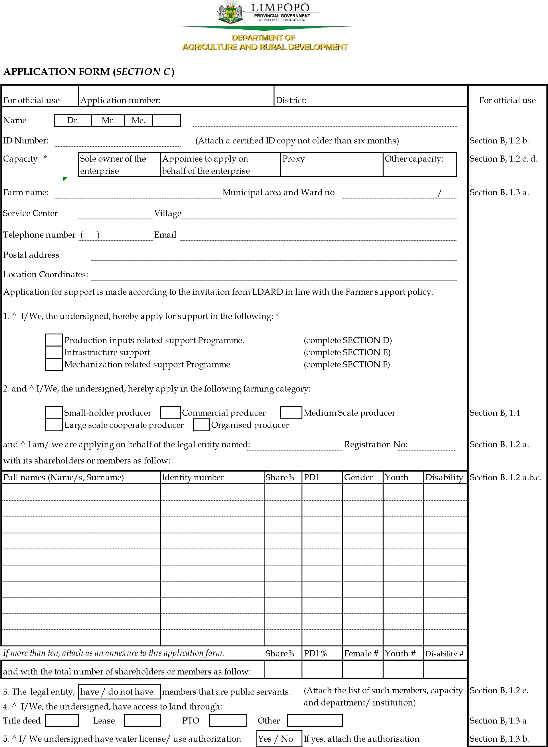
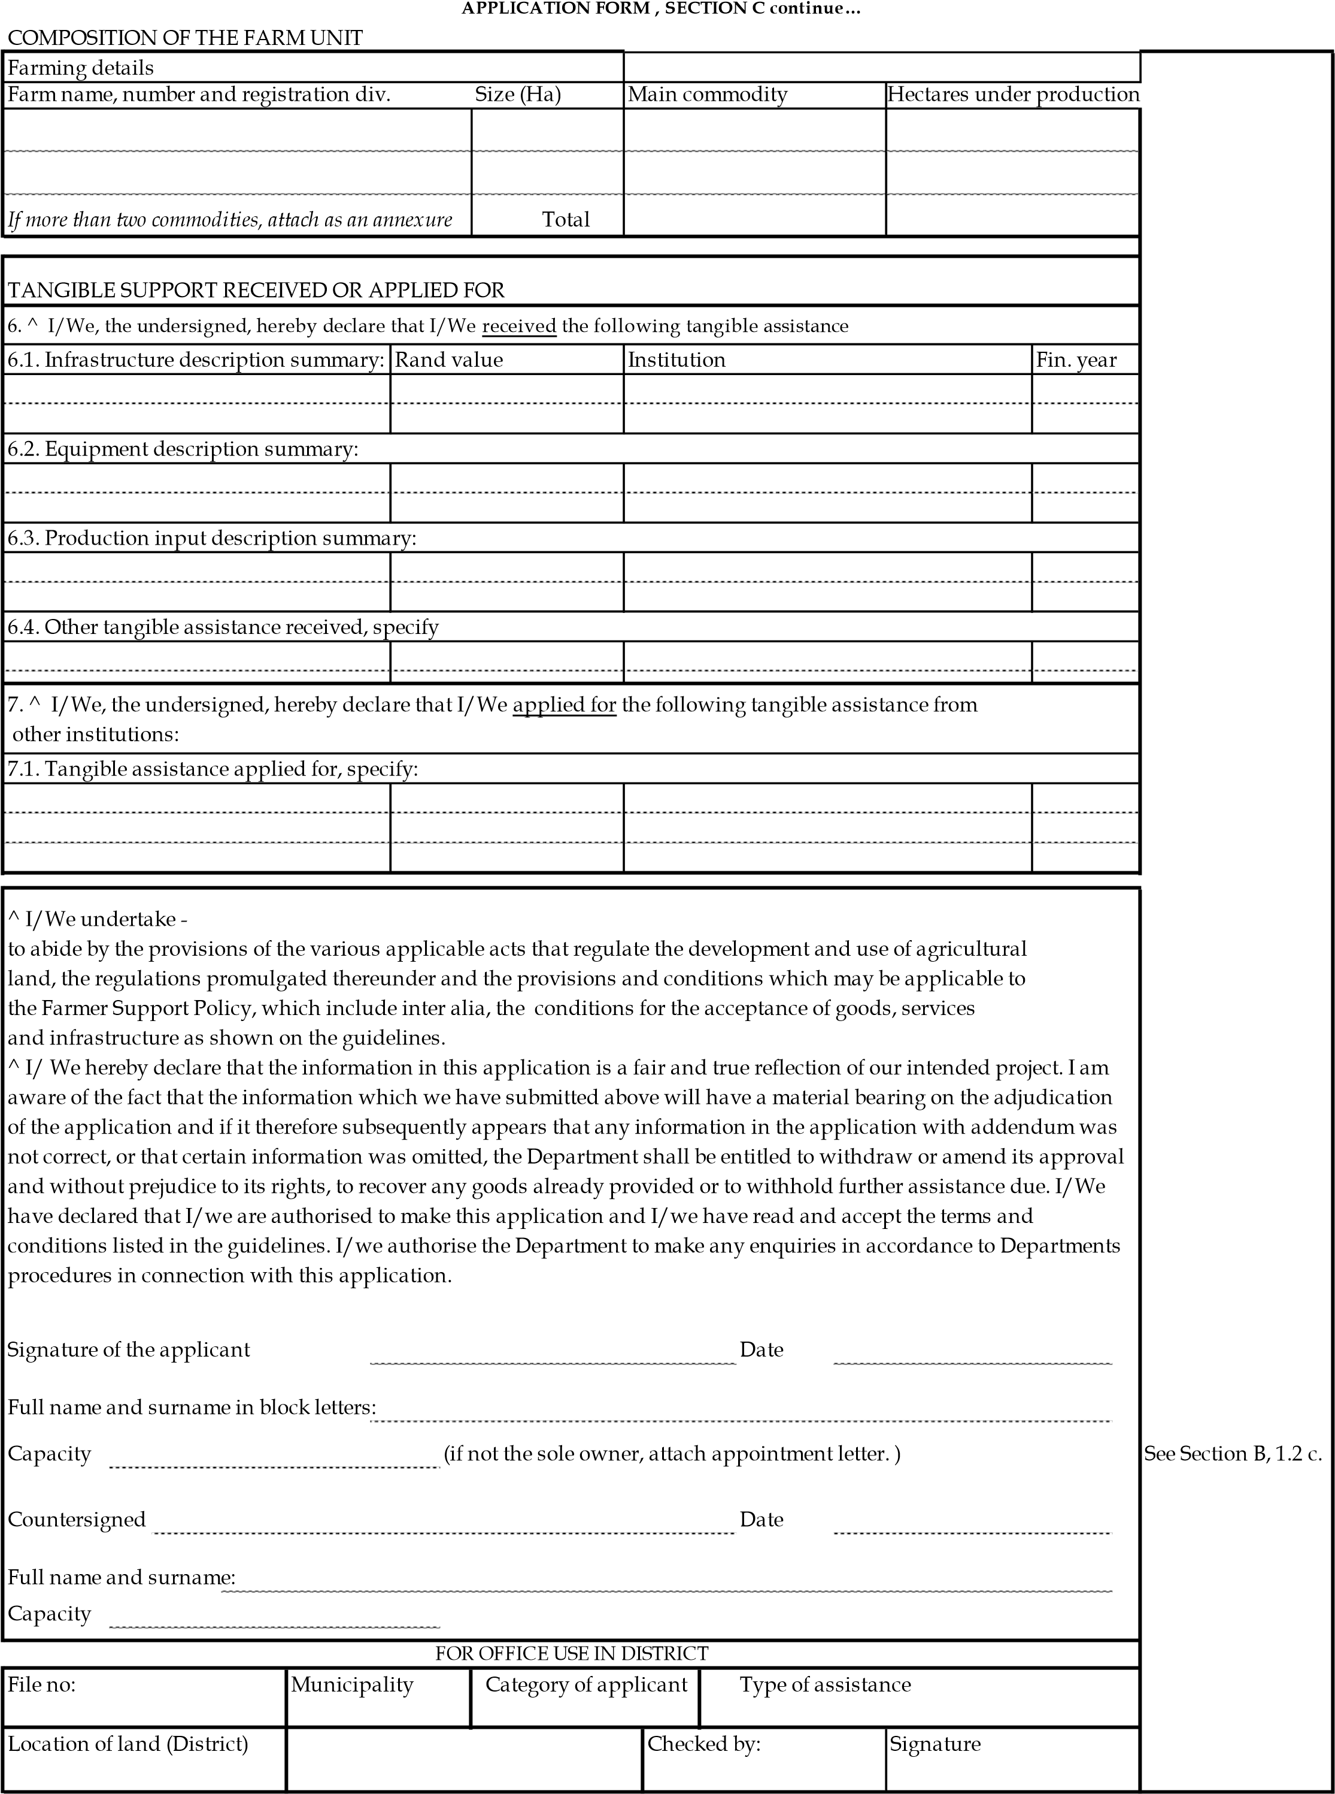

PRODUCTION INPUTS: (SECTION D)
LIVESTOCK PRODUCTION INFORMATION (SECTION D1)
1.1 Indicate number of Livestock you are having
Layers | No. | Broiler | No. |  | Goats | No. | Cattle | No. | Pig | No.
(Total production capacity) |  | (Total production capacity) |  |  | Ewes |  | Heifer |  | Sows
Capacity per cycle |  | Capacity per cycle |  |  | Ram |  | Bull |  | Boar
Sheep | No. | Other Specify:
Ewe
Ram
1.2 Provide the number sold over the past 12 months (Submit the records of sales)
Layers |  | Broiler |  |  | Goats |  | Cattle |  | Pig
Sheep |  | Other specify
1.3 Support requested: Please note that the department might support you with less quantity and alternative related item due to limited budget. (Support will be limited to production capacity where budget allows)
Poultry |  |  | Piggery |  |  | Other Livestock |  | Medication (Specify)
Item | Quantities in bags |  | Item |  | Quantities in bags |  | Quantities  in  bags
Layer  Feeds |  |  | Starter |  |  | Goat
Broiler  Feeds -  starter |  |  | Grower |  |  | Cattle
Broiler  Feed -  Grower |  |  | Finisher |  |  | Sheep
Broiler
Feed
Finisher
Day old
chicks
Pullets
Breeding
Stock
(specify)
Fish breeding stock and production inputs
Any other support specify
1.4 Where are you keeping the livestock?  (provide document if any) |  |  |  | e.g. kraal in the homestead; broiler houses; free range; farm with camps; also indicate carrying capacity
1.5 Indicate the water source
CROP OR HORTICULTURE: (SECTION D2)
2.1 How many hectares are available for production? |  |  |  |  |  |  |  |  |  | 2.2 How many hectares are laying fallow?
2.3 How many hectares you used over the past two season?
2.4 Indicate main commodities you produced over the past two seasons. Use hectares or square meters
 | Ha |  | Ha |  |  |  |  |  | Ha |  |  |  | Indicate if there is any possibility of increasing production- provide clarity  based on water and land availability and any other related resources.
Tomato |  | Cotton |  |  | Citrus
Inion |  | Maize |  |  | Mango
Spinach |  | Sorghum |  |  | Avocadoes
Cabbage |  | Sunflower |  |  | Macadamia
Carrot |  | Beans |  |  | Grapes
Potato |  |  |  |  | Banana
Other |  | Other |  |  | Other
2.5 Describe the available water source.
2.6 Did you obtain water rights? |  |  | Yes |  | No | Submit the proof
2.7 Have you applied for water, right? |  |  |  |  | Yes | No |  | Submit the proof
2.8 Market information over the past two seasons (provide sales records and proof of markets (e.g. letter of intent; agreement)
Commodity - Indicate |  |  |  | Quantities (use kg’s or tonnages) |  |  |  |  |  |  |  | Describe main buyers |  |  |  | Availability of contract (Yes or no)
Tomatoes
Potato
Citrus
2.9 Support requested (Crop and Horticulture): Please note that the department might support you with less quantity and alternative related item due to limited budget (Support will be limited to production capacity where budget allows)
Items |  |  |  | Provide details
Seeds
Chemicals
Fertilizers
Other

INFRASTRUCTURE: (SECTION E)
3.1 Specify value of existing land and infrastructure, Record Of Decision (EIA) and other authorisations utilized to support production (provide proof). This might serve as own contribution.
Item | Value in Rand | Funder | Comment (including capacity)
Land (owned or leased)
Fence and Animal Handling facilities
Irrigation system
Stock water system
Packhouse/shed
Environmental Impact Assessment document
Animal housing structures
Dam/s, water allocation from scheme, borehole
Other
3.2 Support requested: Please note that the department might have limits on the requested infrastructure due to budget availability.
Items | Estimated cost | Provide other details if necessary
Indicate how the above support will improve production:

MECHANIZATION SUPPORT SERVICES: (SECTION F1) –– The support will not exceed 10ha
4.1 Services | Ha | Services | Ha |  | Comment- indicate the current status of the field
Ripping* |  | Disking
Ploughing |  | Planting
Ridging |  | Chemical  Applications
* Ripping will require permission from the LDARD

MECHANIZATION SUBSIDY: (SECTION F2)

Please familiarise yourself with Annexure B of Producer Support Policy

4.2 Do you have any tractor/implements? |  |  | Yes | No
Item | Capacity | Detail Description
e.g. Tractor
4.3 What are you applying for?
Item | Capacity | Detail Description |  |  |  | Estimated Cost if  possible attach quotation

Applicable for Smallholder producers
4.4 How many hectares are you ploughing per season?
4.5 Do you have offtake agreement and provide details? – please attach proof |  |  | Comments:
4.6 Do you have records of sales for the past two production seasons – provide proof |  |  | Comments:
4.7 Are you in good standing with South African Receiver of Revenue? – provide proof e.g. tax clearance |  |  | Comments:
4.8 How often do you use mechanization? |  |  | Once a year | Twice a year | Quite often
4.9 How many hectares in that particular period?
4.10 Do have financial capacity to contribute 20% of the cost? |  |  | Provide proof
4.11 General additional information:
4.12 How are you marketing your produce?
Off take agreement | Yes | No | Other markets provide details

Applicable for Commercial producers
4.13 How many hectares are you ploughing per season?
4.14 Do you have offtake agreement and provide details?  – please attached proof | Comments:
4.14 Do you have records of sales for the past four production seasons – provide proof | Comments:
4.15 Do you have financial capacity to contribute 50% of the required subsidy? | Comment: Funding source
4.16 Are you in good standing with South African  Receiver of Revenue (SARS) | Attach copy of tax clearance
Applicable for Organized Associations/ Commodity groups or Cooperatives
4.17 How long has the company been actively operating? | Provide minutes with attendance registers
4.18 How many hectares are you ploughing per season?
4.19 Do you have offtake agreement and provide details? – please attached proof. | Comments:
4.20 Do you have records of sales for the past three production seasons of individual members– provide proof | Comments:
4.21 Do you have financial capacity to contribute 40% of the required subsidy? | Comment: Funding source
4.22 Are you in good standing with South African  Receiver of Revenue (SARS) | Attach copy of tax clearance

BUSINESS CASE (SECTION G)

NOTE: Complete the business case in full. Those with completed detailed business plan may also attach such to the business case. Applicant can refer to the attached Business Case

1.1 Introduction
TO: |  | Limpopo Department of Agriculture and Rural Development
FROM: |  | …………………………………………………………………… (please insert name of Entity)
SUBJECT: |  | Request for funding for  ……………………………………………………………………  …………………………………………………………………...

1.2 Aim
To request funding from the Limpopo Department of Agriculture and Rural Development
To
………………………………………………………………………………………………………………...… ………………………………………………………………………………………………………………...…

1.3 Background to the project
Describe how the project originated and how it relates to the work and focus of the entity

………………………………………………………………………………………………………………...… ………………………………………………………………………………………………………………...…

1.4 Project description
Provide a detailed description of the project, highlighting (as appropriate) the following:
- The problem or specific constraints the project aims to tackle
- The specific target group the project aims to benefit (geographic focus, sectoral focus, age, gender, race, location)
………………………………………………………………………………………………………………...…
………………………………………………………………………………………………………………...…
………………………………………………………………………………………………………………...… ………………………………………………………………………………………………………………...…

1.5 Main objectives of the project
What are the main objectives of the project?
………………………………………………………………………………………………………………...…
………………………………………………………………………………………………………………...…
………………………………………………………………………………………………………………...…
………………………………………………………………………………………………………………...… ………………………………………………………………………………………………………………...… ………………………………………………………………………………………………………………...…

1.6 Stakeholders
1.6.1 Stakeholder list
List all the potential stakeholders, their interest in this project and their expected role.

1.6.2 Stakeholder assessment
Stakeholder | Description | Inputs required from the stakeholder (incl. financial) | Management implications

1.7 Risks, constraints and assumptions

1.7.1 Constraints
Make a list of all the constraints for the project. Constraints are factors that are outside the control of the project team; that restrict or regulate the project. They affect the performance of the project.

………………………………………………………………………………………………………………...…
………………………………………………………………………………………………………………...… ………………………………………………………………………………………………………………...…

1.7.2 Assumptions
Make a list of all the assumptions for the project. Assumptions are external factors that, at the time of writing the Business Case, are considered true, real or certain for purposes of planning. Certain unverified or unknown aspects that are likely to happen must be included.

………………………………………………………………………………………………………………...…
………………………………………………………………………………………………………………...… ………………………………………………………………………………………………………………...…

1.8 Project organisation and governance
Identify the project champion. Indicate who will be the project manager. Also indicate if there will be a steering committee established.

Project leader
Name
Official title
Telephone
Cell
Facsimile
E-mail

Management team
Project leader (chairperson or Director): …………………………………………
Names of members (specify specific roles or who they represent if appropriate).
………………………………………………………………………………………………………………...…
………………………………………………………………………………………………………………...… ………………………………………………………………………………………………………………...…

1.8.1 Organisation Structure
Explain how the project will be organised. What organisational structure will be adopted? What will the reporting relationships be?
Attach an organisational chart if applicable.

Core Project Team
Determine the required core skills, knowledge and experience needed to achieve the goals and objectives of this project.

………………………………………………………………………………………………………………...…
………………………………………………………………………………………………………………...…
………………………………………………………………………………………………………………...…
………………………………………………………………………………………………………………...…
NB: In case of organised associations/ commodity groups/ cooperatives, please provide prove of the last two meetings of the management structure by attaching the signed minutes and attendance registers.

1.9 Project Partners
Is this project carried out in partnership with other groups/organisations? Are there dependencies with other projects? If yes, identify your partners below. Partners are individuals, groups or organisations who work together towards a joint interest to achieve common goals. Partnership involves shared objectives that are beneficial to two or more parties, but in which the parties play different roles. Keep in mind that effective partnering requires committed leadership, shared purpose and culture, clear governance and accountability, integrated planning, and on-going relationship management.

Partners | Common Interests & Priorities | Roles & Responsibilities

1.10 Employment, job creation and training opportunities
Elaborate on the employment, jobs and training opportunities that will be created through this requested intervention
Current job opportunities created if any | Indicate the number of jobs both temporary and seasonal
• Short-term jobs – after intervention
• Sustainable jobs - after intervention

1.11 Marketing and business production output
- Indicate current marketing arrangement supporting production (provide market agreement if any or
letters of intent)
……………………………………………………………………………………………………………………
- Indicate future marketing arrangements that will support the produce
…………………………………………………………………………………………………………………………
- Indicate current production quantities that the farm is producing
…………………………………………………………………………………………………………………………
- Indicate future production quantities that the farm will be producing once
supported……………………………………………………………………………………………………………
- Indicate the current cost of farm operation and how this was funded
…………………………………………………………………………………………………………………………
- Indicate average turn over that was realised over the past three production seasons, provide proof
………………………………………………………………………………………………………………………… g) Indicate future average turnover
………………………………………………………………………………………………………………………….

1.12 Co-funding (Exclusive of VAT)
GOVERNMENT | OWN |  | Other sources of funding* | Total
Rand (Ex. VAT) |  | Rand (Ex. VAT) | Rand (Ex. VAT) | Rand (Ex. VAT)
LDARD
*Provide a row and clearly indicate each source of funding

1.13 Sustainability of the Project
Briefly describe the sustainability of the project:
- Financially (after funding ends)
- Institutionally (structure to allow activities to continue)
- Multiplier effect

………………………………………………………………………………………………………………...…
………………………………………………………………………………………………………………...…

1.14 Signatures

I/ We hereby declare that the information in this business case is a fair and true reflection of our intended project. I am aware of the fact that the information which we have submitted above will have a material bearing on the adjudication of the application and if it therefore subsequently appears that any information in the application with addendum was not correct, or that certain information was omitted, the Department shall be entitled to withdraw or amend its approval and without prejudice to its rights, to recover any goods already provided or to withhold further assistance due. I/we have read and accept the terms and conditions listed in the guidelines. I/we authorise the Department to make any enquiries in accordance to Departments procedures in connection with this application.

……………………………… …………………………………….
Applicant Capacity
Date:

